Scenario-based Challenges (Basic to intermediate)

Q1. We want to reward our users who have been around the longest.

Find the 5 oldest users.

select top 5 * from users order by created_at asc

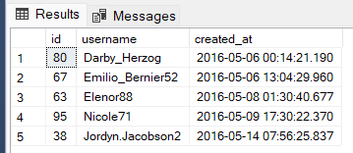

Q.2 What day of the week do most users register on?

We need to figure out when to schedule an ad campgain

select top 1 DATENAME(WEEKDAY, created_at) as day_of_week, count(DATENAME(WEEKDAY, created_at)) as day_count

from users

group by DATENAME(WEEKDAY, created_at)

order by day_count desc

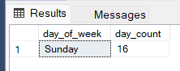

Q3. We want to target our inactive users with an email campaign.

Find the users who have never posted a photo

solution 1:

select * from users where id not in (select user_id from photos)

solution 2:

select u.* from users u left join photos p on u.id = p.user_id

where p.id is null

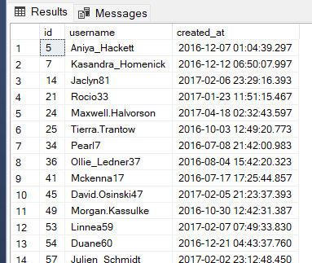

Q4. We're running a new contest to see who can get the most likes on a single photo. find the user who has most liked photo?

select u.username, p.* from photos p join users u on u.id = p.user_id

where p.id in (select top 1 photo_id from likes group by photo_id order by count(photo_id) desc)

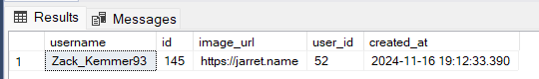

Q5. How many times does the average user post?

select count(*) / (select count(*) from users) as avg_post_per_user from photos

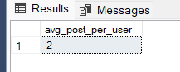

Q6. Get the list of users rankings by posting higher to lower

select u.username, count(user_id) as posts_count from photos p join users u

on u.id = p.user_id

group by p.user_id, u.username

order by posts_count desc

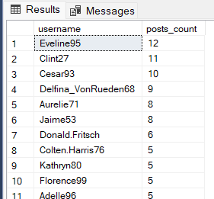

Q7. Total Posts by users (longer version of SELECT COUNT(*) FROM photos)

total numbers of users who have posted at least one time

select count(distinct p.user_id) as count_of_users

from users u join photos p on u.id = p.user_id

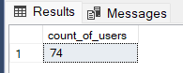

Q8. A brand wants to know which hashtags to use in a post

What are the top 5 most commonly used hashtags?

select top 5 t.tag_name, COUNT(tag_id) as hashtag_count

from photo_tags p join tags t on p.tag_id = t.id

group by tag_id, t.tag_name

order by hashtag_count desc

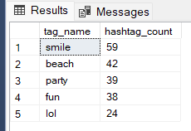

Q9. Find users who have liked every single photo on the site

select u.username, count(user_id) as total_post_likes

from likes l join users u on l.user_id = u.id

group by user_id, u.username

having count(user_id) = (select count(*) from photos)

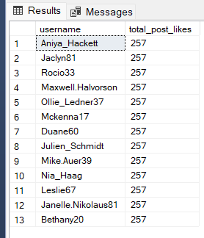

Q10. We also have a problem with celebrities

Find users who have never commented on a photo

select username from users

where id not in (select distinct c.user_id from comments c)

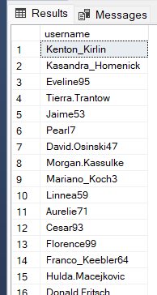

Advanced Scenario questions

Q11. Are we overrun with bots and celebrity accounts?

Find the percentage of our users who have either never commented on a photo or have commented on every photo

WITH CTE as

(

select count(user_id) as count_users_commented from

(select user_id from comments

group by user_id having count(user_id) = (select count(*) from photos)) as T1

),

CTE2 as

(select count(id) as count_users_not_commented from users where id not in (select distinct user_id from comments))

select CTE.count_users_commented, round(CTE.count_users_commented * 100 / (select count(*) from users), 2) as perc,

CTE2.count_users_not_commented, round(CTE2.count_users_not_commented * 100 / (select count(*) from users), 2) as perc

from CTE join CTE2 on 1=1

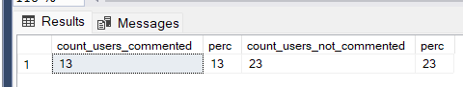

Q12. Are we overrun with bots and celebrity accounts?

Find the percentage of our users who have either never commented on a photo or have liked on every photo

WITH CTE as

(

select count(*) as tot_users_count_not_commented from users where id not in (select user_id from comments)

),

CTE2 as

(

select count(*) as tot_users_like_all_photo from

(select user_id, count(user_id) as tot_users_like_all_photo from likes

group by user_id having count(user_id) = (select count(*) from photos)) as T1

)

select tot_users_count_not_commented, round(tot_users_count_not_commented * 100/ (select count(*) from users), 2) as perc,

tot_users_like_all_photo, round(tot_users_like_all_photo * 100/ (select count(*) from users), 2) as perc

from CTE join CTE2 on 1=1

